Chapter 5

Continuous Random Variables

  - Introduction
- Concept ---
  - In Chapter 4, we consider discrete random variables.
  - There exist random variables whose values are “continuous.”
  - For examples:
    - time that a train arrives at a stop;
    - lifetime of a transistor or a bulb;
    - weight of a human being;
    - …

- Definition 5.1 ---
  - We say that X is a continuous random variable if there exists a nonnegative function f, defined for all real x such that −∞ < x < ∞, which has the property that for any set B of real numbers,
P{X∈B} = 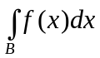.
  - The function f(x) above is called the probability density function (pdf), or simply, the density function, of the random variable X.

- Notations about real-number lines and line segments ---
  - The set of real numbers specified by −∞ < x < ∞ will be denoted as (−∞, ∞), which represents a real-number line depicted by “−∞∞”.
  - So the notations “x ∈ (−∞, ∞),” and “−∞ < x < ∞” are equivalent.
  - Also, the set of real numbers specified by a ≤ x < b will be specified as [a, b), which represents a real-number line segments “a b”.
  - So [a, b] means a ≤ x ≤ b and is represented as “a b”; and (a, b) means a < x < b and is represented as “a b”, and so on.

- Concept from histogram, through pmf, to pdf ---
  - A histogram is a graph for depicting the distribution of a set of sample values, with the x-axis specifying possible discrete sample values and the y-axis specifying the number of samples of each sample value. Here, each sample value may be regarded as a random variable value.
  - The graph of the pmf depicts the probability of each possible discrete sample value, as defined before.
  - The graph of the pdf depicts the probability mass of each unit-length strip centered at each continuous sample value, as defined above.
  - An example of the shapes of these three types of graphs for the samples of an identical random variable is shown in Fig. 5.1.

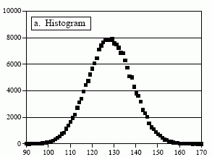 |  | 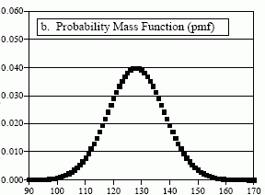
(a) A histogram with x-axis specifying sample values & y-axis specifying # samples. |  | (b) A pmf with x-axis specifying sample values & y-axis specifying probability values.
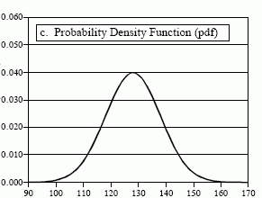
(c) A pdf with x-axis specifying sample values & y-axis specifying probability density function values.
Fig. 5.1 Graphs of the histogram, pmf, and pdf of a sample data set, all similar in shape.

- Some properties of the pdf ---
  - The pdf for a continuous random variable corresponds to the pmf for a discrete random variable, as shown in Fig. 5.1.
  - The pdf f(x) for a random variable X satisfies the following property of Axiom 2 of probability:
1 = P{X ∈ (−∞, ∞)} = 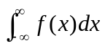.
  - All questions about X can be answered in terms of the pdf f(x).
    - If B = [a, b], then
P{X ∈ B} = P{a ≤ X ≤ b} = 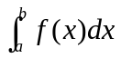.
That is, the value P{a ≤ X ≤ b} is just the area under the curve of the pdf f(x), as illustrated in Fig. 5.2.

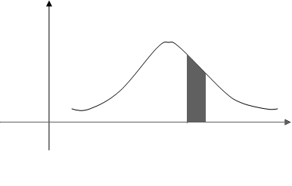
f(x)
x
a
b
Fig. 5.2 Curve of pdf f(x) where the value of P{a ≤ X ≤ b} is just the shaded area.

    - If a = b, then
P{X = a} = 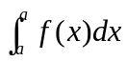 = 0.
That is, the probability of a continuous random variable at a specific value is zero! Contrarily, for a discrete random variable X, P{X = a} is just the pmf p(a) of X, which might not be zero.

    - Finally, we have
P{X < a} = P{X ≤ a} = 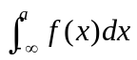
which is just the cdf value F(a) of X at a, i.e.,
F(a) = .

- Example 5.1 ---
The amount of time that a computer functions before breaking down is a continuous random variable X with its pdf given by
f(x) = λe^{−x/100} when x ≥ 0;
= 0 when x < 0.
(a) What is the probability that a computer will function for a period of time between 50 and 150 hours before breaking down?
(b) What is the probability that it will function for a time period of less than 100 hours?
Solution for (a):
  - Since = 1 = 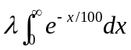, we get , after integration, 1 = 100λ, and so λ = 1/100.
  - Hence the desired probability of (a) is
P{50 < X < 150} = 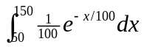
= 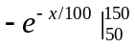
= 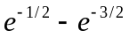
≈ 0.384.
Solution for (b):
  - The desired probability of (b) is
P{X < 100} = 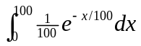
= 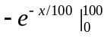
= 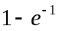
≈ 0.633.

- Relation between the cdf and the pdf ---
  - Fact 5.1 ---
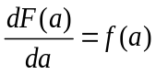.
Why? Recall the cdf F(a) = 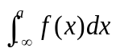.
  - That is, the pdf is the differentiation result of the cdf.

- A note about terms ---
  - Whenever ambiguity will not arise, the cdf of a random variable X will also be called simply as the distribution of X. Therefore, cumulative distribution function (cdf), distribution function, and distribution are all identical terms.
  - By analogy, we also use simply density for the probability density function (pdf), so probability density function (pdf), density function, and density are all of identical meanings.

- Intuitive interpretation of the pdf ---
  - We have the probability
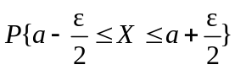 = 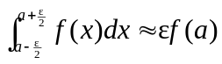
which, as ε → 0, means the “slim” area (of the shape of a strip) around x = a under the curve of the pdf f(x) (see Fig. 5.3 for an illustration).
  - So, f(a) is just a measure of how likely it is that the random variable will be near a.
  - Also, as ε → 0, we have
→ P{X = a} = εf(a) → 0
where the notation “→” means “approach.”
  - That is, for a continuous random variable X, the probability for the event “X = a” is zero! However, this is not true for a discrete random variable.

a−ε/2 a a+ε/2
f(x)
_{x}
Fig. 5.3 Illustration of ≈ εf(a) around f(a) under the curve of pdf f(x).

  - Expectation and Variance of Continuous Random Variables
- Concept ---
  - Recall the expectation of a discrete random variable X:
E[X] = 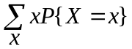 = 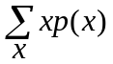
where p(x) is the pmf of X.
  - For the continuous case, the probability mass P{X = x} is may be computed by
P{x ≤ X ≤ x + dx} ≈ f(x)dx
for small dx.
  - Therefore, we get the analogue definition of the expected value for the continuous case as follows.

- Definition of the expectation of a continuous random variable ---
  - Definition 5.2 ---
The expectation (expected value, mean) of a continuous random variable X is defined as
E[X] = 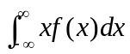.
- Example 5.2 ---
The pdf of a random variable X is given by
f(x) = 1 if 0 ≤ x ≤ 1;
= 0 otherwise.
Find E[e^{X}] where e^{X} is an exponential function of X.
Solution:
  - Define a new random variable Y = e^{X}.
  - To compute E[Y], we have to know pdf f_{Y}(y) of random variable Y.
  - This can be done by computing the cdf F_{Y} of Y at first.
  - For 1 ≤ y ≤ e, with the abbreviation ln meaning natural logarithm we have
F_{Y}(y) = P{Y ≤ y}
= P{e^{X} ≤ y}
= P{X ≤ ln(y)}
= 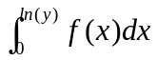
= ln(y).
  - Differentiating F_{Y}(y), we get the pdf of Y as
f_{Y}(y) = 1/y for 1 ≤ y ≤ e.
  - For y elsewhere, obviously f_{Y}(y) = 0.
  - So, the desired expected value is
E[Y] = 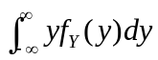 = 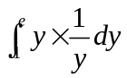 = 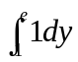 = e − 1.
  - There is a faster way to compute E[Y], which comes from the following proposition.

- Proposition 5.1 ---
If X is a continuous random variable with pdf f(x), then for any real-valued function g, we have
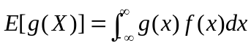.
Proof: The proof may be done by an analogue of the proof for the corresponding proposition of the discrete case (Proposition 4.1); see the reference book for the detail.

- Example 5.3 (Example 5.2 revisited) ---
Find E[e^{X}] where X is as specified in Example 5.2.
Solution:
  - Since f(x) = 1 for 0 ≤ x ≤ 1; 0, otherwise, by Proposition 5.1 we get
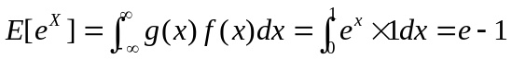
which is identical to the result obtained in Example 5.2.

- Corollary 5.1 ---
If a and b are constants, then
E[aX + b] = aE[X] + b.
Proof: see the reference book.

- Definition of variance of a continuous random variable ---
  - Definition 5.3 ---
The variance of a continuous random variable X is defined as
Var(X) = E[(X − μ)²]
where μ = E[X].

- Proposition 5.2 ---
Var(X) = E[X²] − (E[X])².
Proof: see the reference book.

- Example 5.4 ---
The pdf of a random variable X is given by
f(x) = 2x if 0 ≤ x ≤ 1;
= 0 otherwise.
Find Var(X).
Solution:
  - 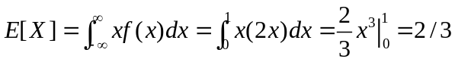.
  - 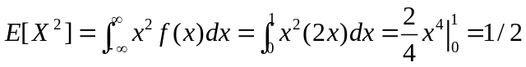.
  - So
Var(X) = E[X²] − (E[X])²
= 1/2 − (2/3)²
= 1/18.

- Corollary 5.3 ---
Var(aX + b) = a²Var(X).
Proof: see the reference book.

  - Uniform Random Variables
- Definition of uniform random variable ---
  - Definition 5.4 ---
We say that X is a standard (unit) uniform random variable over (0, 1) if its pdf is given by
f(x) = 1 if 0 < x < 1;
= 0 otherwise.
  - By this definition, the probability for X to be in any particular subinterval of (0, 1) is equal to the length of the subinterval because
P{a ≤ X ≤ b} = 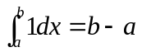.
  - Definition 5.5 (generalization of Definition 5.4) ---
We say that X is a uniform random variable, or simply, that X is uniformly distributed, over (a, b) if its pdf is given by
f(x) = 1/(b − a) if a < x < b;
= 0 otherwise.
  - A diagram for the curve of the pdf of a uniform random variable X is shown in Fig. 5.4.

f(x)
1/(b − a)
a
b
x
Fig. 5.4 A diagram for the pdf of a uniform random variable X.

- The cdf of a uniform random variable ---
  - Fact 5.2 ---
The cdf of a uniform random variable X is
F(x) = 0 if x ≤ a;
= (x − a)/(b − a) if a < x < b;
= 1 if x ≥ b.
Proof: easy; as an exercise.

  - A diagram for the cdf of a uniform random variable X is shown in Fig. 5.5.

- Example 5.5 ---
Random variable X is uniformly distributed in (a, b). Find the mean and the variance of X.
Solution:
  - The mean is 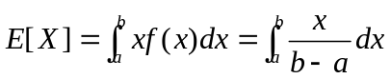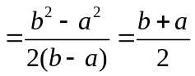.
  - 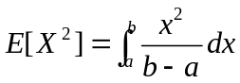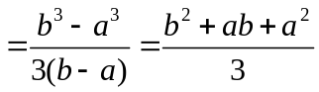.
  - So the variance is Var(X)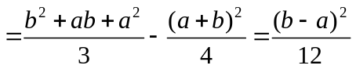.

F(x)
1
a
b
x
Fig. 5.5 A diagram for the cdf of a uniform random variable X.

- Example 5.6 ---
Buses arrive at a specified stop at 15-minute intervals starting at 7:00 am. That is, they arrive at 7:00, 7:15, 7:30, and so on. If a passenger arrives at the stop at a time that is uniformly distributed between 7:00 and 7:30, find the probability that he waits for (a) less than 5 minutes for a bus; (b) more than 10 minutes for a bus.
Solution for (a):
  - Let random variable X = the number of minutes past 7:00 that the passenger arrives at the stop.
  - Then its pdf is: f(x) = 1/30 0 ≤ x ≤ 30; 0 elsewhere.
  - The passenger has to wait less than 5 minutes if he arrives between 7:10 and 7:15 or between 7:25 and 7:30. So the probability is
P{10 < X < 15} + P{25 < X < 30} 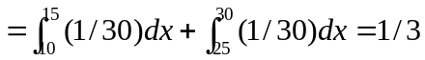.
Solution for (b):
  - The passenger has to wait more than 10 minutes if he arrives between 7:00 and 7:05 or between 7:15 and 7:20.
  - So the probability is
P{0 < X < 5} + P{15 < X < 20} = 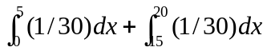 = 1/3.

  - Normal Random Variables
- Definition of normal random variable ---
  - Definition 5.6 ---
We say that X is a normal random variable, or simply, that X is normally distributed, with parameters μ and σ² if its pdf is given by
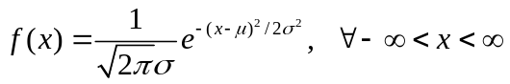.
  - We denote the above random variable by X~N(μ, σ²), in which the letter N means normal.
  - The above function f(x) is indeed a pdf because it can be shown that
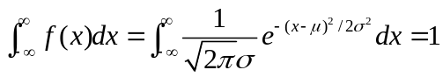
(see the reference book for the detail of this proof).
  - The curve of the pdf of the normal random variable is of a bell shape which is symmetric about μ (see Fig. 5.6 for an illustration).

μ
−2σ
+2σ
f(x)
x
Fig. 5.6 A diagram for the bell-shaped pdf curve of a normal random variable.

  - Examples of Normal random variable ---
    - the height of a man;
    - the error made in measuring a physical quantity;
    - the velocity of gas molecules;
    - the grade of a student in a test (if the grade is regarded as a continuous real number instead of a discrete one);
    - …

- Some facts about normal random variables ---
  - Fact 5.3 ---
If X is normally distributed with parameters μ and σ², then its mean and variance are just the parameters, respectively, i.e., we have (a) E[X] = μ and (b) Var(X) = σ².
Proof of (a)***:
    - At first from Definition 5.2 we have
E[X] = = 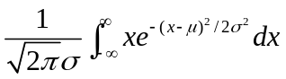.
    - Writing x as (x + μ) − μ, we get from the above equality the following equation:
E[X] = 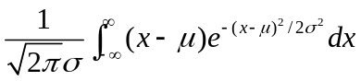 + 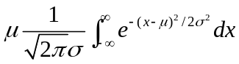.
    - By letting y = x − μ in the first integral of the above equality so that dy = dx, we get
E[X] = 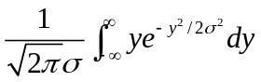 + 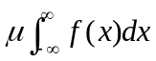 (A)
where f(x) denotes the pdf of X.
    - By symmetry of integration, the first integral in the above equation is equal to zero.
    - Furthermore, by Axiom 2 we have 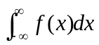=1.
    - Accordingly, we get from (A) above the first desired result:
E[X] = = μ.
Proof of (b)***:
    - Since E[X] = μ, by Definition 5.3 we have Var(X) = E[(X − μ)²].
    - By Proposition 5.1 (for computation of the mean of a function of a random variable): , we have
Var(X) = E[(X − μ)²]
= 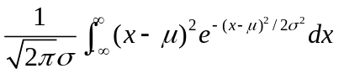. (B)
    - Let y = (x − μ)/σ, or equivalently, x = σy + μ so that dx = σdy and (x − μ)² = σ²y².
    - Accordingly, (B) above becomes
Var(X) = 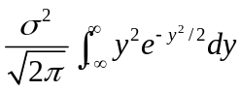. (C)
    - To apply the rule of integration by parts in calculus: ∫udv = uv − ∫vdu, let u = y and v = −e^{−y2/2} so that
∫udv = ∫yd(−e^{−y2/2}) = ∫y(ye^{−y2/2})dy = ∫y²e^{−y2/2}dy;
uv − ∫vdu = −ye^{−y2/2} + ∫e^{−y2/2}dy.
Therefore,
∫y²e^{−y2/2}dy = −ye^{−y2/2} + ∫e^{−y2/2}dy.
    - Accordingly, (C) leads to
Var(X) =
= 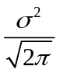[−ye^{−y2/2}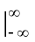 + 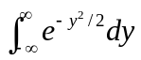]
= −ye^{−y2/2} + 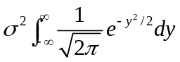. (D)
    - By symmetry, the first term in the above equality can be seen to be zero.
    - The part 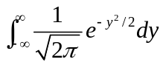 in the second term obviously is the integration of the pdf f(y) = 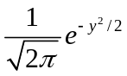of a normal random variable Y with parameters (0, 1), i.e., with mean E[Y] = 0 and variance Var(Y) = 1, so that we have = 1 by Axiom 2 mentioned in Chapter 2.
    - Accordingly, (D) above becomes Var(X) = σ²×1 = σ². Done.

  - A note: the above fact says that a normal random variable can be uniquely determined by its mean and variance.

  - Fact 5.4 ---
If X is normally distributed with parameters μ and σ², then Y = aX + b is normally distributed with parameters aμ + b and a²σ², i.e., Y~N(aμ + b, a²σ²).
Proof:
    - From Corollaries 5.1 and 5.3 as well as the results of Fact 5.3, we have
E[Y] = E[aX + b] = aE[X] + b = aμ + b,
Var(Y) = Var(aX + b) = a²Var(X) = a²σ². (E)
That is, Y has mean aμ + b and variance a²σ².
    - But this is not a complete proof of this fact because we do not know yet if Y is normally distributed or not.
    - The cdf of Y is
F_{Y}(y) = P{Y ≤ y} = P{aX + b ≤ y} = P{X ≤ (y − b)/a} = F_{X}((y − b)/a)
= 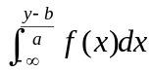 (here f(x) is the pdf of X)
= 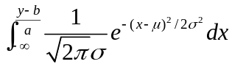. (F)
    - Let z = ax + b, then x becomes x = (z − b)/a, and we have the partial derivative dz = adx, or equivalently, dx = (1/a)dz.
    - Also, the upper limit of the integration in (F) above (y − b)/a becomes a × [(y − b)/a] + b = y − b + b = y.
    - Then, (F) above now becomes
F_{Y}(y) =
= 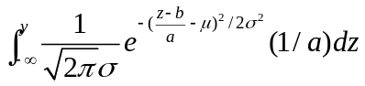
= 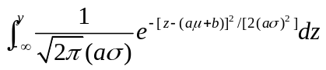
= 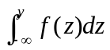
where
f(z) = 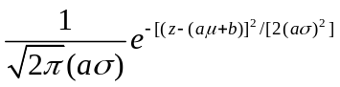
is the pdf of random variable Y because Y has mean aμ + b and variance a²σ² as derived previously (see (E)), and this pdf has the form of that of a normal random variable.
    - Therefore, by Definition 5.6 we get to know that Y = aX + b is normally distributed with mean aμ + b and variance (aσ)² = a²σ². Done.

  - Fact 5.5 ---
If X is normally distributed with parameters μ and σ², then Z = (X − μ)/σ is normally distributed with parameters 0 and 1, i.e., Z~N(0, 1).
Proof:
    - Let Z = (1/σ)X + (−μ/σ) = aX + b with a = 1/σ, b = −μ/σ.
    - Using the last fact, we get
Z~N(aμ + b , a²σ²)
= N((1/σ)×μ + (−μ/σ), (1/σ²)×σ²)
= N(0, 1).
Done.

- Unit normal distribution ---
  - The random variable Z~N(0, 1) mentioned in Fact 5.5 above is said to be standard or unit normal, or to have the standard or unit normal distribution.
  - The cdf of a standard normal random variable is denoted by Φ(x), i.e.,
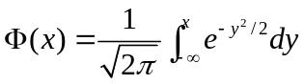.
  - Note that Φ(x) is just the area under the curve of the pdf f(x) and to the left of x, as illustrated in Fig. 5.7 (the shaded area in the figure).
  - Note that the curve of f(x) is symmetric with respect to the mean μ = 0.
  - The values of Φ(x) for all x ≥ 0 are listed in Table 5.1.

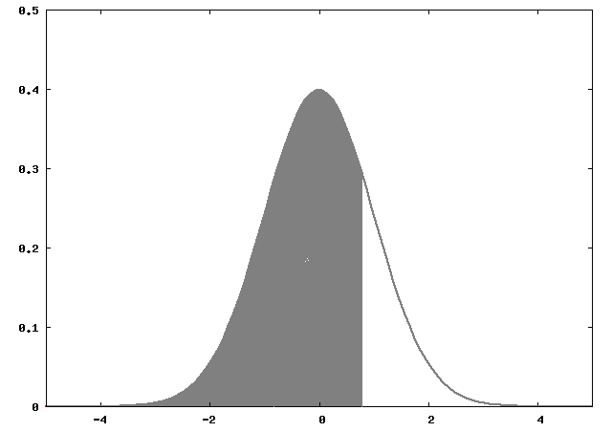
Fig. 5.7 The pdf curve of standard normal distribution with shaded area = cdf value Φ(x).

  - Fact 5.6 ---
For negative x, Φ(x) may be computed by
Φ(−x) = 1 − Φ(x) −∞ < x < ∞.
Why? The proof is left as an exercise (hint: use the symmetry of the curve of the pdf).

  - Fact 5.7 ---
For a standard random variable Z, we have
P{Z ≤ −x} = P{Z > x} −∞ < x < ∞.
Proof:
From the last fact, we get
P{Z ≤ −x} = Φ(−x)
= 1 − Φ(x)
= 1 − P{Z ≤ x}
= P{Z > x}.

Table 5.1 Area Φ(x) under the standard normal pdf curve to the left of x.
Z | 0.00 | 0.01 | 0.02 | 0.03 | 0.04 | 0.05 | 0.06 | 0.07 | 0.08 | 0.09
0.0 | 0.5000 | 0.5040 | 0.5080 | 0.5120 | 0.5160 | 0.5199 | 0.5239 | 0.5279 | 0.5319 | 0.5359
0.1 | 0.5398 | 0.5438 | 0.5478 | 0.5517 | 0.5557 | 0.5596 | 0.5636 | 0.5675 | 0.5714 | 0.5753
0.2 | 0.5793 | 0.5832 | 0.5871 | 0.5910 | 0.5948 | 0.5987 | 0.6026 | 0.6064 | 0.6103 | 0.6141
0.3 | 0.6179 | 0.6217 | 0.6255 | 0.6293 | 0.6331 | 0.6368 | 0.6406 | 0.6443 | 0.6480 | 0.6517
0.4 | 0.6554 | 0.6591 | 0.6628 | 0.6664 | 0.6700 | 0.6736 | 0.6772 | 0.6808 | 0.6844 | 0.6879
0.5 | 0.6915 | 0.6950 | 0.6985 | 0.7019 | 0.7054 | 0.7088 | 0.7123 | 0.7157 | 0.7190 | 0.7224
0.6 | 0.7257 | 0.7291 | 0.7324 | 0.7357 | 0.7389 | 0.7422 | 0.7454 | 0.7486 | 0.7517 | 0.7549
0.7 | 0.7580 | 0.7611 | 0.7642 | 0.7673 | 0.7704 | 0.7734 | 0.7764 | 0.7794 | 0.7823 | 0.7852
0.8 | 0.7881 | 0.7910 | 0.7939 | 0.7967 | 0.7995 | 0.8023 | 0.8051 | 0.8078 | 0.8106 | 0.8133
0.9 | 0.8159 | 0.8186 | 0.8212 | 0.8238 | 0.8264 | 0.8289 | 0.8315 | 0.8340 | 0.8365 | 0.8389
1.0 | 0.8413 | 0.8438 | 0.8461 | 0.8485 | 0.8508 | 0.8531 | 0.8554 | 0.8577 | 0.8599 | 0.8621
1.1 | 0.8643 | 0.8665 | 0.8686 | 0.8708 | 0.8729 | 0.8749 | 0.8770 | 0.8790 | 0.8810 | 0.8830
1.2 | 0.8849 | 0.8869 | 0.8888 | 0.8907 | 0.8925 | 0.8944 | 0.8962 | 0.8980 | 0.8997 | 0.9015
1.3 | 0.9032 | 0.9049 | 0.9066 | 0.9082 | 0.9099 | 0.9115 | 0.9131 | 0.9147 | 0.9162 | 0.9177
1.4 | 0.9192 | 0.9207 | 0.9222 | 0.9236 | 0.9251 | 0.9265 | 0.9279 | 0.9292 | 0.9306 | 0.9319
1.5 | 0.9332 | 0.9345 | 0.9357 | 0.9370 | 0.9382 | 0.9394 | 0.9406 | 0.9418 | 0.9429 | 0.9441
1.6 | 0.9452 | 0.9463 | 0.9474 | 0.9484 | 0.9495 | 0.9505 | 0.9515 | 0.9525 | 0.9535 | 0.9545
1.7 | 0.9554 | 0.9564 | 0.9573 | 0.9582 | 0.9591 | 0.9599 | 0.9608 | 0.9616 | 0.9625 | 0.9633
1.8 | 0.9641 | 0.9649 | 0.9656 | 0.9664 | 0.9671 | 0.9678 | 0.9686 | 0.9693 | 0.9699 | 0.9706
1.9 | 0.9713 | 0.9719 | 0.9726 | 0.9732 | 0.9738 | 0.9744 | 0.9750 | 0.9756 | 0.9761 | 0.9767
2.0 | 0.9772 | 0.9778 | 0.9783 | 0.9788 | 0.9793 | 0.9798 | 0.9803 | 0.9808 | 0.9812 | 0.9817
2.1 | 0.9821 | 0.9826 | 0.9830 | 0.9834 | 0.9838 | 0.9842 | 0.9846 | 0.9850 | 0.9854 | 0.9857
2.2 | 0.9861 | 0.9864 | 0.9868 | 0.9871 | 0.9875 | 0.9878 | 0.9881 | 0.9884 | 0.9887 | 0.9890
2.3 | 0.9893 | 0.9896 | 0.9898 | 0.9901 | 0.9904 | 0.9906 | 0.9909 | 0.9911 | 0.9913 | 0.9916
2.4 | 0.9918 | 0.9920 | 0.9922 | 0.9925 | 0.9927 | 0.9929 | 0.9931 | 0.9932 | 0.9934 | 0.9936
2.5 | 0.9938 | 0.9940 | 0.9941 | 0.9943 | 0.9945 | 0.9946 | 0.9948 | 0.9949 | 0.9951 | 0.9952
2.6 | 0.9953 | 0.9955 | 0.9956 | 0.9957 | 0.9959 | 0.9960 | 0.9961 | 0.9962 | 0.9963 | 0.9964
2.7 | 0.9965 | 0.9966 | 0.9967 | 0.9968 | 0.9969 | 0.9970 | 0.9971 | 0.9972 | 0.9973 | 0.9974
2.8 | 0.9974 | 0.9975 | 0.9976 | 0.9977 | 0.9977 | 0.9978 | 0.9979 | 0.9979 | 0.9980 | 0.9981
2.9 | 0.9981 | 0.9982 | 0.9982 | 0.9983 | 0.9984 | 0.9984 | 0.9985 | 0.9985 | 0.9986 | 0.9986
3.0 | 0.9987 | 0.9987 | 0.9987 | 0.9988 | 0.9988 | 0.9989 | 0.9989 | 0.9989 | 0.9990 | 0.9990

  - Fact 5.8 ---
The cdf value F_{X}(a) of a normal random variable X with parameters μ and σ² at a may be expressed by the value of the standard normal random variable Z as
F_{X}(a) = Φ(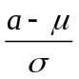).
Proof:
    - From Fact 5.5, we know Z = (X − μ)/σ has a standard normal distribution.
    - So, we have
F_{X}(a) = P{X ≤ a}
= P{(X − μ)/σ ≤ (a − μ)/σ}
= P{Z ≤ (a − μ)/σ}
= Φ().

- Example 5.7 ---
If X is a normal random variable with parameters μ = 3 and σ² = 9, find (a) P{2 < X < 5}; (b) P{X > 0}; and (c) P{|X − 3| > 6}.
Solution:
(a) P{2 < X < 5} = 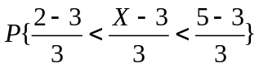
= P{−1/3 < Z < 2/3}
= Φ(2/3) − Φ(−1/3)
(by properties of continuous random variable)
= Φ(2/3) − [1 − Φ(1/3)] (by Fact 5.6)
≈ Φ(0.67) + Φ(0.33) − 1
= 0.7486+ 0.6293 − 1 (by Table 5.1)
= 0.3779
(b) P{X > 0} = 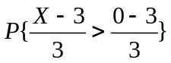
= P{Z > −1}
= P{Z ≤ 1} (by Fact 5.7)
= Φ(1)
≈ 0.8413. (by Table 5.1)
(c) P{|X − 3| > 6} = P{X − 3 > 6 or X − 3 < −6}
= P{X > 9} + P{X < −3}
= 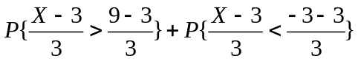
= P{Z > 2} + P{Z < −2}
= P{Z ≤ −2} + P{Z < −2} (by Fact 5.7)
= Φ(−2) + Φ(−2) (P{Z = −} = 0)
= 2(1 − Φ(2)) (by Fact 5.6)
≈ 2×(1 − 0. 9772) (by Table 5.1)
= 2×0.0228
= 0.0456.

- A note about the name of “normal” distribution ---
  - The distribution was first used by the French mathematician Abraham De Moivre in 1733 with the name “exponential bell-shaped curve” for approximating probabilities related to coin tossing.
  - The distribution became more useful when the German mathematician Karl Friedrich Gauss used it in 1809 in his method for predicting the location of astronomical entities, and was called the Gaussian distribution since.
  - During the second half of the 19th century, the British statistician Karl Pearson led people to use the new name normal distribution for the bell-shaped curve because at the time more and more data sets were found to have this distribution, resulting in people’s acceptance of it as a normal data distribution.

- Normal approximation to the Binomial Distribution ---
  - A recall of the definition of the binomial random variable ---
If X represents the number of successes in n independent trials with p as the probability of success and 1 − p as that of failure in a trial, then X is called a binomial random variable with parameters (n, p).

  - The DeMoivre-Laplace Limit Theorem ---
If S_{n} denotes the number of successes that occur when n independent trials, each with a success probability p, are performed, then for any a < b, it is true that
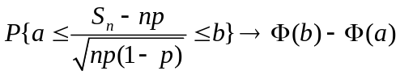
as n → ∞ (note: S_{n} is a random variable here).
Proof: the above theorem is a special case of the central limit theorem of Chapter 8, and so will be proved there.

- A note: now, we have two approximations to the Binomial distribution:
    - Poisson approximation --- used when n is large and np moderate;
    - Normal approximation --- used when np(1 − p) is large (generally quite good when np(1 − p) ≥ 10).

- Example 5.8 ---
Let X be the number of times that a fair coin, flipped 40 times, lands head (i.e., has the head as the outcome). Find the probability that X = 20. Use the normal approximation and then compare it to the exact solution.
Solution:
  - X is a binomial random variable and can be approximated by the normal distribution because np = 40×0.5 = 20; np(1 − p) = 40×0.5×(1 − 0.5) = 10.
  - By the DeMoivre-Laplace Limit Theorem, the normal approximation of P{X = 20} may be computed as:
P{19.5 < X < 20.5} = 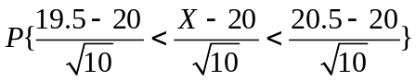
= 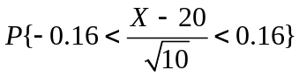
≈ Φ(0.16) − Φ(−0.16)
= Φ(0.16) − [1 − Φ(0.16)]
= 2×Φ(0.16) − 1
= 2×0.5636 − 1
= 0.1272.
  - The exact binomial distribution value of P{X = 20} is:
P{X = 20} = C(40, 20)×(0.5)²⁰(1 − 0.5)²⁰
= 137846528820 × (0.5)⁴⁰
= 137846528820 × 9.094947017729282379150390625e⁻¹³
≈ 0.1254
which is close to 0.1272.

(Note: the combination C(40, 20) may be computed online at the following IP: http://stattrek.com/Tools/EventCounter.aspx, and the value (0.5)⁴⁰ by a calculator or computer program.)

  - Exponential Random Variables
- Revisit of the Poisson random variable ---
  - Review of use of the Poisson random variable ---
    - We already know from Fact 4.8 of the last chapter that as an approximation of the binomial random variable, a Poisson random variable X can be used to specify
“the number of successes occurring in n independent trials, each of which has a success probability p, where n is large and p is small enough to make np moderate”
in the following way:
P{X = i} ≈ 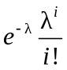 i =1, 2, ...
where the parameter of X is λ = np.

    - Examples of applications of the above use of the Poisson random variable ---
        - No. of misprints on a page of a book.;
        - No. of people in a community living to the age of 100;
        - No. of wrong telephone numbers that are dialed in a day;
        - ....

  - Another use of the Poisson random variable ---
    - Fact 5.9 ---
It can be shown that a Poisson random variable N also can be used to specify
“the number of events occurring in a fixed time interval of length t”
in the following way under certain assumptions (see the reference for the detail of the assumptions):
P{N(t) = i} = 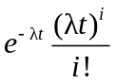 i =1, 2, ...
where the parameter of N is λt with λ being the rate per unit time at which events occur.
Proof: see the reference book.

    - Definition 5.7 ---
An event which can be described by the above Poisson random variable is said to occur in accordance with a Poisson process with rate λ.

    - Examples of applications of the above use (all assumed to satisfy the above-mentioned assumptions) ---
        - No. of earthquakes occurring during some fixed time span;
        - No. of wars per year;
        - No. of wrong-number telephone calls you receive in a fixed time duration;
        - …

- Example 5.9 ---
Assume that earthquakes occur in the western part of the US in accordance with the Poisson process with rate λ = 2 with 1 week as the unit of time (i.e., earthquakes occur 2 times every week). (a) Find the probability that at least 3 earthquakes occur during the next 2 weeks. (b) Find the probability that the time starting from now until the next earthquake is not greater than t.
Solution of (a):
  - With the fixed time interval t = 2 weeks, by the first and second axioms of probability and Fact 5.9, we have
P{N(t) ≥ 3} = 1 − P{N(2) = 0} − P{N(2) = 1} − P{N(2) = 2}
= 1 − e⁻⁴ − 4e⁻⁴ − (4²/2)e⁻⁴
= 1 − 13e⁻⁴.
Solution of (b):
  - Let the time starting from now until the next earthquake be denoted as a random variable X. Then, X will be greater than t if and only if no event occurs within the next fixed time interval of t, i.e.,
P{X > t} = P{N(t) = 0} = = 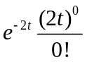 = e^{−2t}.
  - Therefore, the desired probability that the time starting from now until the next earthquake is not greater than t may be computed to be
P{X ≤ t} = 1 − P{X > t} = 1 − e^{−2t} = 1 − e^{−λt} with λ = 2.
which is just the cdf of X.

- A comment and a fact ---
  - The result of part (b) of Example 5.9 may be generalized to be the following fact.
  - Fact 5.10---
The amount of time from now till the occurrence of an event, which takes place in accordance with the Poisson process with rate λ, may be described by a random variable X with the following cdf:
F(t) = P{X ≤ t} = 1 − e^{−λt}.

- Definition of exponential random variable ---
  - Definition 5.8 ---
A continuous random variable X is called an exponential random variable with parameter λ if its pdf is given by
f(x) = λe^{−λx} if x ≥ 0;
= 0 if x < 0.

- The cdf of an exponential random variable ---
  - The cdf of an exponential random variable X with parameter λ is given by
F(a) = P{X ≤ a} = 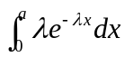 = 1 − e^{−λa} for a ≥ 0.

  - The above cdf is just that of the random variable mentioned previously in Fact 5.10, and so we get the following fact.

  - Fact 5.11 ---
The distribution (i.e., the cdf) of the amount of time from now till the occurrence of an event, which takes place in accordance with the Poisson process with rate λ, may be described by the distribution of the exponential random variable, called exponential distribution hereafter.

  - In other words, the exponential distribution often arises, in practice, as being the distribution of the amount of time until some specific event occurs. Some additional examples are:
    - the amount of time until an earthquake occurs;
    - the amount of time until a new war breaks out;
    - the amount of time until a telephone call you receive is a wrong number, etc.

- The mean and variance of the exponential random variable ---
  - Fact 5.12 ---
The exponential random variable X has the following mean and variance:
E[X] = 1/λ;
Var(X) = 1/λ².
Proof: see the reference book.

- Example 5.10 ---
Suppose that the length of a phone call in minutes is an exponential random variable with parameter λ = 1/10. If some one arrives immediately before you at a phone booth, find the probability that you will have to wait (a) more than 10 minutes; (b) between 10 and 20 minutes.
Solution for (a):
  - Let random variable X denote the length of call made by the person, which is just the time until the event that the person stops making phone call in the booth.
  - Then, by Fact 5.11, X has an exponential distribution given by
F(a) = P{X ≤ a} = = 1 − e^{−λa} a ≥ 0.
  - The desired probability is P{X > 10} = 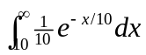 ≈ 0.368.
Solution for (b):
  - The desired probability is P{10 < X <20} = 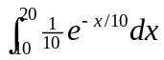 ≈ 0.233.

  - The Distribution of a Function of a Random Variable
- How to compute the cdf of a function of a random variable?
  - Suppose that we want to compute the distribution of g(X) given the distribution of X.
  - To do so, we need to express the event of g(X) < y in terms of corresponding values of X collected as a set.

- Example 5.11 ---
Let X be uniformly distributed over (0, 1). We want to obtain the distribution of the random variable Y = X^{n}.
Solution:
  - By Fact 5.2, we have the cdf of random variable X as
F(x) = 0 if x ≤ a;
= (x − 0)/(1 − 0) = x if 0 < x < 1;
= 1 if x ≥ b.
  - 0 ≤ y ≤ 1, we have
F_{Y}(y) = P{Y ≤ y} = P{X^{n} ≤ y} = P{X ≤ y^{1/n}}
= F_{X}(y^{1/n}) = y^{1/n}. (F_{X}(x) = x).
  - Therefore, by Fact 5.1 the pdf for Y is
f_{Y}(y) = dF_{Y}(y)/dy = (1/n)y^{(1/n)−1} 0 ≤ y ≤ 1;
= 0 otherwise.

- Example 5.12 ---
Let X be a continuous random variable with pdf f_{X}, find the distribution and density of Y = X².
Solution:
  - F_{Y}(y) = P{Y ≤ y} = P{X² ≤ y} = P{−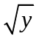≤ X ≤} = F_{X}() − F_{X}(−).
  - Therefore,
f_{Y}(y) = d[F_{Y}(y)]/dy
= {d[F_{X}()]/d()}×[d()/dy] − {d[F_{X}(−)]/d(−)}×[d(−)/dy]
= f_{X}()×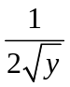 − f_{X}(−)×(−)
= [f_{X}() + f_{X}(−)].

- A comment ---
  - From the above examples, we can see the correctness of the following theorem.

- Theorem 5.1 (computing the pdf of a function of a random variable) ---
Let X be a continuous random variable with pdf f_{X}. Suppose that g(x) is a strictly monotone (increasing or decreasing) differentiable (and thus continuous) function of x. Then, the random variable Y = g(X) has the following pdf:
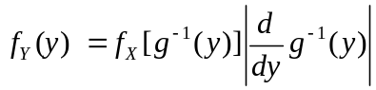 if y = g(x) for some x;
= 0 if y ≠ g(x) for all x,
where g⁻¹(y) is defined as that value of x such that g(x) = y.
Proof.
(a) When g(x) is an increasing function ---
  - Suppose y = g(x) for some x so that x = g⁻¹(y).
  - Recall g(X) ≤ y means the event such that g(x) ≤ y is true, which equivalently is the event X ≤ g⁻¹(y) such that x = g⁻¹(y) is true.
  - Accordingly, with Y = g(X) the cdf F_{Y}(y) of Y may be derived in the following way:
F_{Y}(y) = P{Y ≤ y} (by definition of cdf)
= P{g(X) ≤ y}
= P{X ≤ g⁻¹(y)}
= F_{X}(g⁻¹(y)). (by definition of cdf)
  - Therefore,
f_{Y}(y) = dF_{Y}(y)/dy (by Fact 5.1)
= d[F_{X}(g⁻¹(y))]/d(g⁻¹(y)) × d(g⁻¹(y))/dy
= f_{X}(g⁻¹(y))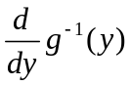
where 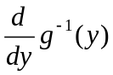 is nonnegative because g⁻¹(y) is nondecreasing (g(x) is increasing).
(b) When g(x) is a decreasing function ---
  - The derivation is all the same as above except that becomes negative.
  - Therefore, to keep f_{Y}(y) positive, we have the following result
f_{Y}(y) = f_{X}(g⁻¹(y))[−].
(c) Combining the results of (a) and (b) above ---
  - We get
if y = g(x) for some x.
(d) When y ≠ g(x) for any x ---
  - When y ≠ ∞, F_{Y}(y) = P{Y ≤ y} = P{g(X) ≤ y} = P(φ) = 0, where φ is the empty set.
  - And when y = ∞, F_{Y}(y) = P{Y ≤ y} = P(S) = 1 where S is the sample space.
  - For either case, f_{Y}(y) = dF_{Y}(y)/dy = 0. Done.

- Example 5.13 (Examples 5.11 & 5.12 revisited using the above theorem) ---
Let X be a continuous nonnegative random variable with pdf f_{X}, find the distribution of Y = X^{n} and X².
Solution:
  - Given g(x) = x^{n}, we get g⁻¹(y) = y^{1/n}.
  - And 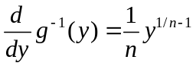.
  - From Theorem 7.1, we get the pdf for Y as 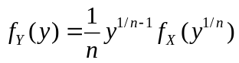.
  - For uniformly distributed random variable X over (0, 1), the above result is
f_{Y}(y) = 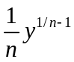 0 ≤ y ≤ 1; (0 ≤ y^{n/1} ≤ 1 so that f(y^{n/1}) = 1)
= 0 otherwise,
consistent with the result of Example 5.11.
  - When n = 2, we get 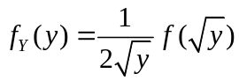 which is in agreement with the result of Example 5.12 (Why? Because X is nonnegative so that the second term f_{X}(−) with negative input − in the result of Example 5.12 is zero).

